Case study 1: Strategising for improvement oriented Purchasing

Memorandum for the Chair, Purchasing Unit

Dear colleagues,

I draw your attention to the attached report from Health Systems Intelligence Ltd at Attachment 1. Among other matters the report shows that:

- About 50% of a hospital’s inpatient and day case activity would benefit from clinical pathway development and implementation.

- Significant allocative efficiency gains would be available from by improving service provision for long term conditions in primary care

- Significant technical efficiency gains are available in most hospitals by

- Reorganising care process in ways that lowered average length of stay along lines that were equal to or better than the national average

- Improving its day case ratio for each high volume DRG to a level that was equal to or better than the national average.

In light of its findings, Health Systems Intelligence Ltd recommends that:

- The LHB and service providers (the hospital and GPs) should support the development of integrated clinical pathways (ICPs) for all high volume case types, be they elective admissions, day cases or admissions through Accident and Emergency. Please note the emphasis on ICPs that are aimed at better managing chronic conditions in primary care. Health Systems Intelligence argues that the introduction of this approach to managing its demand would produce significant allocative efficiencies for LHBs and the health economies as a whole.

- The LHB and service providers should address quality and clinical governance issues posed by low volume elective admissions.

Viewed from the perspective of purchasing these findings raise questions about:

- The availability of data as outlined in the report and who should be responsible for their routine production in the future
- How the purchasing processes can be structured to pursue issues outlined in report and
- How we should we prioritise our work over the next three years and who should do what, when and how about matters raised in the report.
- What priority should we give to pathway (clinical process) development and implementation? If so, which conditions (DRGs) should we concentrate on over the next three years and how might we go about this?

I look forward to your advice.

David Green
Chair, Regional Purchasing Unit
April 25th 2013

Attachment 1: An analysis of ‘patient activity’ within Yetholme Hospital Trust
Health Systems Intelligence Ltd, Durham, 12 January 2013

Attachment 1: An analysis of ‘patient activity’ within Yetholme Hospital Trust
Health Systems Intelligence Ltd, Durham, 12 January 2013

Executive Summary

This report presents findings following an analysis of clinical activity within Yetholme Hospital Trust. The analysis covers admitted patients only. It does not include clinical activity in respect of non admitted Accident and Emergency patients nor does it include activity in out-patient clinics. These areas will be dealt with in a subsequent report

The analysis revealed the following main findings for the period 2006-2012.

- About 50% of the Trust’s inpatient and day case activity would benefit from clinical pathway development and implementation. The basis for this findings become clear when we considered the findings that

- 40 DRGs accounted for 40% of all emergency admissions,
- 40 DRGs accounted for 60% of elective inpatient admissions,
- 40 DRGs accounted for 84% of all day cases
- 10 DRGs accounted for 98% of maternity (& birth) admissions and 97% of maternity and birth bed days.

- The clinical conditions suitable for pathway based systematisation would need to be determined via more detailed investigations (with clinicians) of the case types within each DRG broken down by International Classification of Diseases 10 (ICD10) or Office of Population and Census Statistics (OPCS) codes.

- The trust could pursue significant technical efficiency gains by:

- Reorganising care process in ways that lowered average length of stay along lines that were equal to or better than the national average

- Improving its day case ratio for each high volume DRG to a level that was equal to or better than the national average.

- The trust should support the development of integrated clinical pathways aimed at better managing chronic conditions in primary care. The introduction of this approach to managing its demand would produce significant allocative efficiencies for LHBs and the health economies as a whole.

The Trust together with other Trusts and LHBs in the region should address quality and clinical governance issues posed by low volume elective admissions. The range of potential technical and allocative efficiency savings are illustrated in Table 1 below.

Table 1: Per day bed savings that would derive from alternative technical and allocative efficiency strategies
 |  | Equal to National Average | 5% better than national average | 10% better than national average
Technical Efficiency | ALOS | 5 | 7 | 9
Technical Efficiency | DCR | 1.2 | 1.4 | 1.5
Allocative Efficiency | Reduce  Readmissions | 11 | 11 | 11
Allocative Efficiency | Role Delineation | 0.5 | 0.5 | 0.5
 | Total | 17.7 | 19.9 | 22

Introduction

This report presents findings of analysis of clinical activity within Yetholme Hospital Trust. The analysis covers admitted patients only and hence does not include clinical activity in respect of patients who presented at Accident and Emergency and were not admitted nor does it include activity associated with out-patient clinics. Activity in these areas will be dealt with in a subsequent report.

Method

Data Source

The analysis is based on de-identified PEDW data for YH Trust for the years 2006-2012. From April 2010, PEDW has been available in a normalised form (i.e. the values of certain items for previous years have been modified so that, where possible, they conform to contemporary standards.) This analysis utilises the normalise data thus enabling across–year comparison and interpretation.

Data cleaning

Although the NHS Trust activity data-returns are cleaned by PEDW, data errors do occur. The nature and form of these errors often depends upon the Patient Admission Systems from which the data was supplied. Data problems encountered in the YH Trust data set were as follows.

- The same patient was entered under different PAS patient identification numbers. Systematic occurrence of this error produces serious distortions in rates of admission for particular conditions.

- An episode of care was entered more than once leading to duplicate episodes. This error can lead to serious distortions in the analysis of the mean lengths of stay.

- Providers of care were classified by provider codes that were in use at the time that the care was provided rather than the provider codes currently in use. The number of major re-organisations of NHS Trusts over the last 8 years, together with changes in provider code and the formal closing of spells associated with such a change, complicate attempts to track activity by providers over time.

- There were duplicate records in relation to incomplete birth episodes and/or periods of augmented care.

The last three problems were eliminated using routines that check the consistency of episodes across a spell using the formal rules used to define the various fields. Characteristically these routines assume the truth of the values of particular fields such as patient identification number, admission and discharge date to detect inconsistencies across other fields. The data discussed in this report has been subjected to these routines.

Our approach to data analysis

We began with simple questions such as what are the high volume case types admitted through A&E? What were the high volume case types admitted as elective cases? What was the average length of stay (ALOS) for these case types? How did ALOS for each case type within YH Trust compare with the national average? As we increased our understanding of the pattern of activity within YH Trust we asked more specific questions and the data interrogation requirements became more searching. The following discussion progresses in a similar fashion.

Findings

High volume case types amenable to pathway development and implementation

We mapped activity according to the three prime categories of admission, namely admissions through A&E, elective admissions, day case admissions.

Table 2 (over the page) reports the top 40 emergency admission by DRG calculated as a yearly for the years 2006-2010. The data are arranged by decreasing volume.

The data show that

- 40 DRGs accounted for 46% of all emergency admissions

- broken down by clinical specialty, 14% of all A&E admissions referenced cardiac conditions (E Code), 6.75% referenced abdominal conditions (F code), 5.5% conditions of the respiratory system (D code), 3.78% falls (H code) and Paediatrics 7.63% (P code)

- 7 of the top 10 A&E admissions referenced conditions such as COPD, asthma, IHD, heart failure with a demonstrated high risk of readmission (shaded cells in the table)

- admission for these ‘high risk re-admission’ DRGs accounts for about 15% of the bed days expended on all accident and emergency admissions.

Table 2: high volume emergency admissions, YH Trust (average of 2006-2010 financial years inclusive)

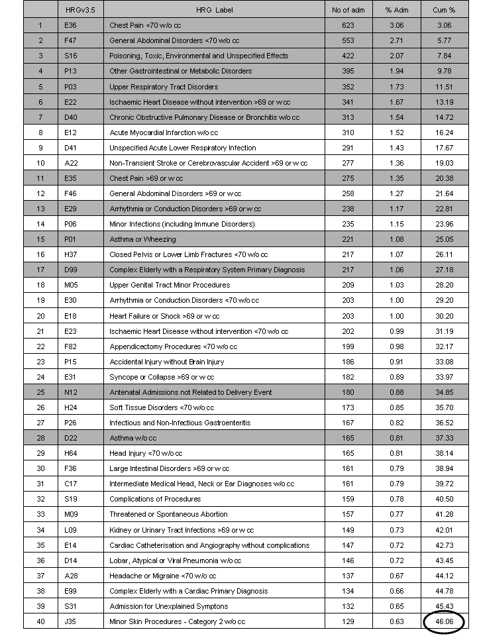
Adm = admission, Cum = cumulative percentage
*Shaded cells indicate the DRGs with high rates of repeat admissions.

Within maternity and obstetrics care a very small number of DRGs (10) accounted for almost all emergency activity (98%) (refer Table 3).

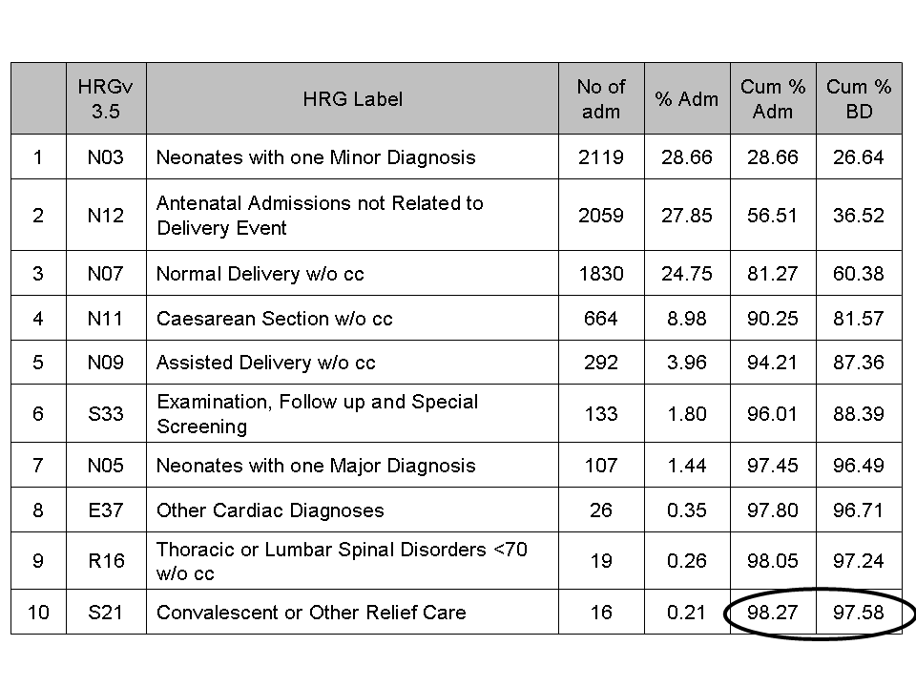
Table 3: High volume maternity & birth admissions with bed days
(Values for number of admissions and bed days averaged over the period 2006-2011)

The pattern of relatively few DRGs accounting for a large proportion of the Trust’s clinical work was also evident elective case types

Tables 4 and 5 show that, in the period 2006-2012

- 40 DRGs accounted for 61% of inpatient elective activity and
- 40 DRGs accounted for 84% of day case activity

We suggest that the care processes used in treating the conditions/procedures included in the DRGs are prime candidates for the development and implementation of integrated clinical pathways

We also note the high number of cases in respect of both elective inpatient activity and day cases that have been coded DRG S22 (Planned Procedures Not Carried Out) - elective inpatient activity 212 and day cases 286. The reasons for these should be investigated.

Table 4: high volume elective inpatient admissions, YH Trust
(Values for the number of admissions and bed days averaged over the period 2006-2012)

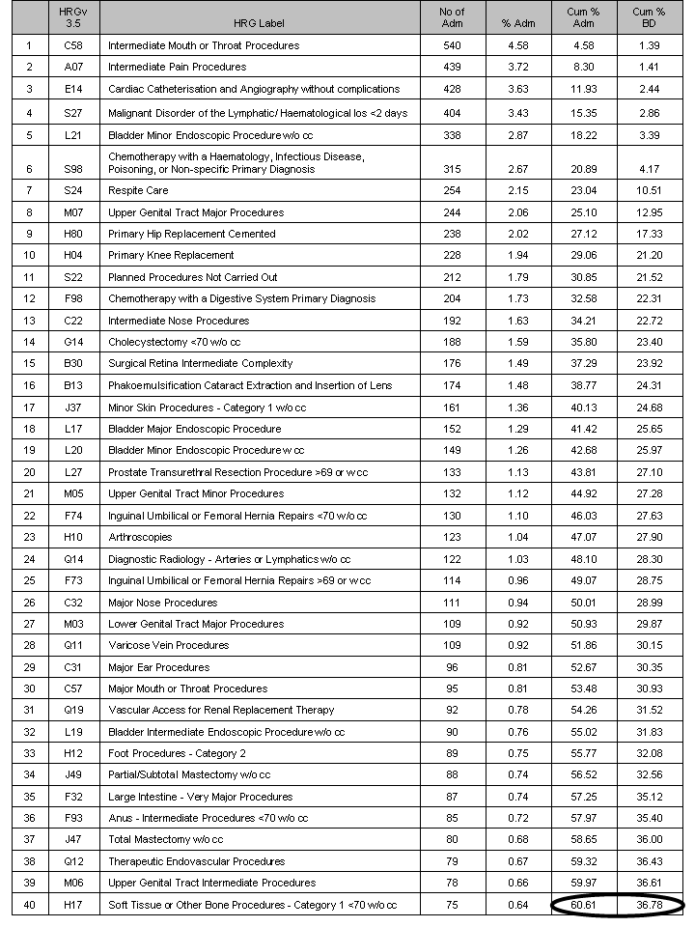

Table 5: high volume elective day case procedures, YH Trust

(Values for the number of admissions averaged over the period 2006-2012)

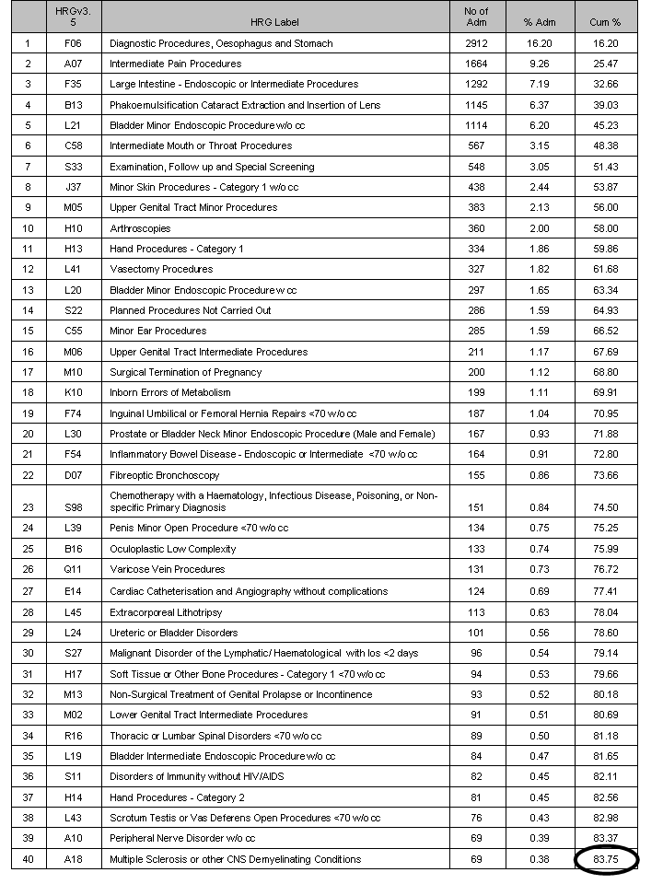

The tables also show case types that were common to both the top 40 elective inpatient admissions and the top 40 day case admissions. As illustrated in Table 6 below, 13 DRGs were common to both high volume elective inpatient admissions and day cases.

Table 6: YH Trust day case rates for high volume day cases compared with day case rates within other Trusts in the region and the National Day Case Rate (2009/10)

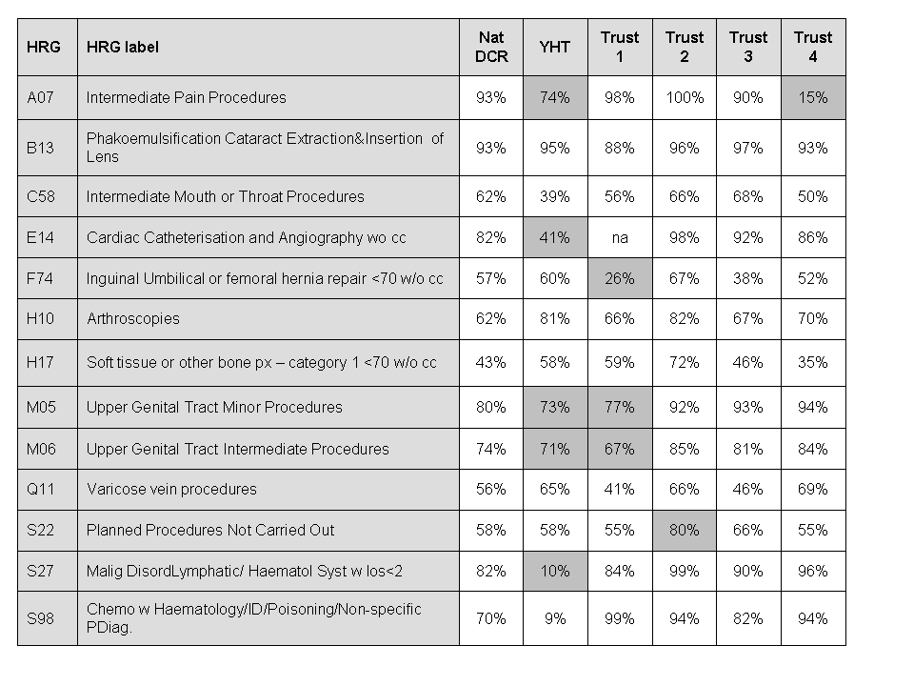

In light of this finding we compared the day case rates (DCRs) for these procedures with those of other trusts in the Region. The differences between trusts in the percentages of elective activity performed as day cases were notable. For example ‘Intermediate Pain Procedures’ (A07) in NV Trust had a day case percentage of 74%; this contrasted poorly with the national average of 93% and Trusts 1, 2 and 3.

While these differences may reflect differences in the medical staff composition of each Trust, particularly among surgical specialists, they may also reflect variations in clinical practice and the organisation of the care process. The reasons for this variability should be determined.

Limitations in using HES data to map a hospital’s casemix

Health Related Group (DRG) classifications are resource based constructs that group clinical conditions that use broadly similar amounts of clinical resources. That said however it also the case that the same clinical condition can be included in more than one DRG. This occurs, for example when patient exhibits several co-morbidities or complications which increase the average amount of resources required in their treatment. Where this occurs one DRG will include patients without co-morbidities or complications and another will include patients with co-morbidities or complications.

An DRG is assigned on the basis of the International Classification of Diseases version 10 (ICD-10) codes that have been assigned to the primary diagnosis for an admission that is recorded in the patient’s discharge summary at the time of their discharge from hospital. While DRG classification and ICD 10 classifications overlap to a large degree, this ‘fact’ masks as much as it reveals in ways that has important clinical and organisational ramifications. For example, the level of clinical aggregation inherent in DRG based data of its nature ‘irons-out’ the clinical differences between patients whose diagnosis have been assigned the same DRG code.

What may be involved here becomes apparent when we consider chronic obstructive pulmonary disease (COPD). Within the ICD-10 coding system, COPD falls within the respiratory chapter, J44: Other Chronic Obstructive Pulmonary Disease, and is mainly classified into three primary codes, J441, J449 and J440. Within the DRG system, however, COPD is classified according to two DRGs, D40 COPD or bronchitis without co-morbidities and complications, and D39 COPD or bronchitis with co-morbidities and complications. There is also a third DRG which may include COPD. This is DRG D99, a more generic DRG, references complex elderly cases who have a primary diagnosis concerning the respiratory system.

Table 7 shows that, over a five year period in five similar trusts, three ICD 10 codes accounted for 96.7% of admissions within DRG D40. The remaining 3.3% of COPD admissions formed a long ‘tail’ of other ICD 10 codes. These codes refer to respiratory diseases, some of which are, to a non-clinician, apparently little different from other ICD 10 respiratory codes. The same was true for admissions recorded under DRG D39 (not depicted) however these patients had longer average lengths of stay, reflecting the presence of co-morbidities and/or complications.

Table 7: Breakdown of DRG D40 (COPD or bronchitis without CC) by ICD 10 codes for

admissions in the years 2006/07 - 2010/11

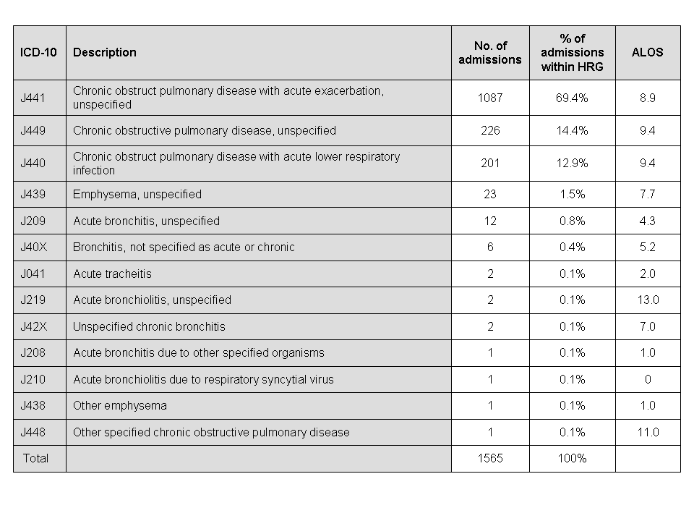

However, not all cases with a primary diagnosis code of J44 were assigned to DRGs D39, D40 or D99. As illustrated in Table 7 some patients whose primary diagnosis was coded J44 were assigned other DRGs although in small numbers only. These patients may have been under investigation or having treatment for some other condition simultaneously with their COPD. Alternatively, the assigned DRG may reference a procedure that takes precedence over the primary diagnosis as is the case with H88 i.e. an emergency due to a fractured neck of femur.

Table 8: DRG assignment of cases with primary diagnosis J44: other chronic obstructive pulmonary disease (2006/07 - 2010/11)
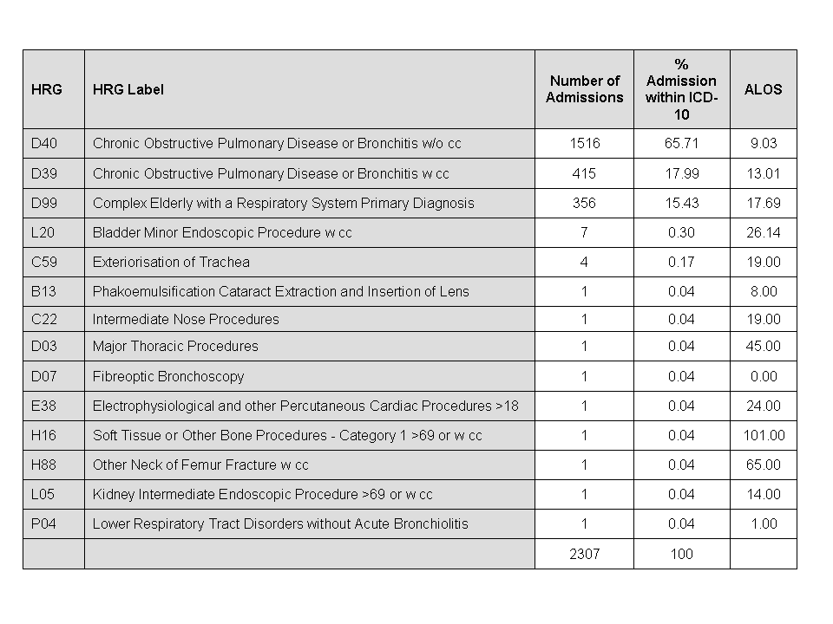

In summary the data presented in Tables 7 and 8 suggest that while DRG data are useful as a ‘first-cut’ in understanding the ‘casemix’ of patients that constitutes the workload of HV Trust, a more detailed understanding of the range of clinical processes in which the hospital is involved and the resource usage patterns that result from existing approaches to treating nominated case types only becomes available through an analysis ICD10 based data for that condition. In this regard the COPD data presented in Tables 7 and 8 stimulate questions such as:

- How many of the 226 patients whose admissions were coded as J499 could have been managed in primary care?

- To what extent does the hospital care for a patient admitted with COPD with a lower respiratory infection (J440) differ from that used in treating a patient with an acute exacerbation unspecified (J441)

- How does age, clinical complexity and co-morbidity affect hospital based clinical treatment? And how do these factors impact on resource usage?

Insights into the impact of these factors became available when we considered the data set out in Table 9 which reports the frequency of secondary diagnoses among YH Trust patients whose primary diagnosis was coded as J44 (ICD10) in the years 2006/07 to 2010/11.

Table 9: Impact of secondary diagnosis and age on treatment and resource usage for patients with primary diagnosis J44 (2006/07 to 2010/11)

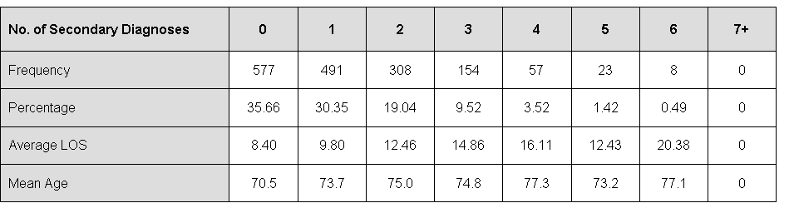

The table shows that 36% of patients with COPD had no secondary diagnoses, 30% had one secondary diagnosis, and 34% had two or more secondary diagnoses. As might be expected, resource usage in treating these patients (as indicated by ALOS values) increased as did their clinical complexity.

An analysis of YH Trust’s technical efficiency

Insights into the YH Trust’s technical efficiency become available by comparing the:

- Average length of stay (ALOS) for each DRG within YH Trust with the national ALOS for each DRG

- Day case ratio (DCR) for each elective case type within YH Trust with the national DCR for each of these case types.

These comparisons, in turn, provided basis for calculating:

- Potential bed day savings gained by decreasing the average length of stay (ALOS) for each DRG in line with designated criteria (i.e. equal to the national average, 5% better than national average, or 10% better than national average).

These standards were based on trimmed data, that is, the data set excludes admissions in which the length of stay was in excess of the maximum normally expected for the DRG. The point on the range at which the trimming occurs (i.e. the ‘trim point,’) is set nationally for each DRG. We used trimmed data because the national tariff for each DRG is based on these and because complexities associated with exceptional length of stays can be excluded.

- Potential bed day savings gained by increasing the day case ratio for elective admissions for each DRG in line with nominated criteria as above^{3.}

Average Length of Stay

Table 13 below reports the total bed-day savings that would result for YH Trust if the ALOS for each DRG (in 2010) had been in line with the national average, 5% better than the national average or 10% better that national average. Table A15 then reports the percentage of beds within all hospitals in the Great Western Region that could be saved if ALOS was reduced for each DRG in all hospitals.

Table 13: Potential Bed-Day Savings For YH Trust
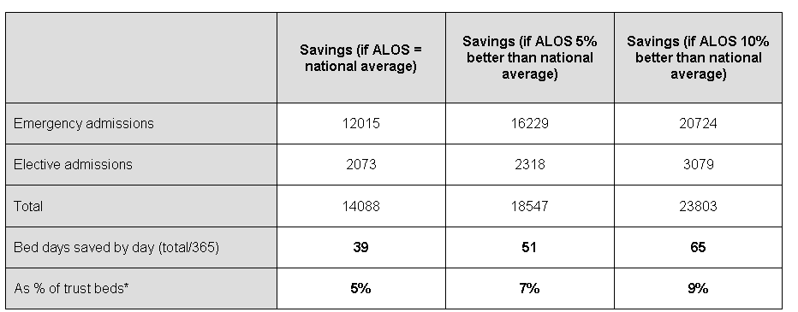
*Based on NV Trust having 718 beds

Table 16: Percentage of beds that could be saved across the Region if ALOS for each DRG was reduced to designated standards

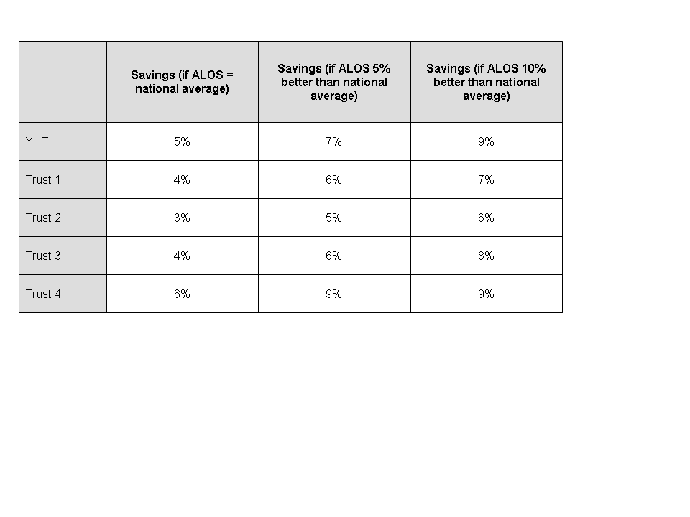

The tables demonstrate that YH Trust could reduce its bed usage by 5% per day if its ALOS for each DRG was equal to the national average and that this figure doubled in the event that the ALOS for each DRG was reduced to 10% lower than the national average. The data in Table 16 show that these potential savings were in line with other Trusts in the Region. On a different tack the data presented in Table 15 indicate that relatively fewer savings were to be found in elective admissions as compared with emergency cases.

Low volume case types

Further analysis, however, revealed that the potential for saving varied depending on the volume of admissions within individual DRGs and that this was most evident in low volume elective admissions defined as DRGs with less than twenty admissions per year.

Table 17: Volume based differences in potential annual bed-day savings for YH Trust if ALOS for each DRG was equal to the national average
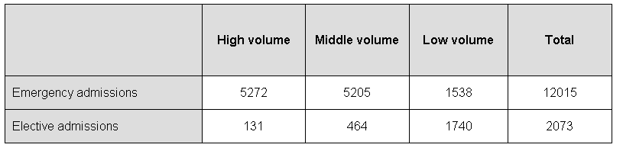

The data for emergency admissions in Table 17 show that potential annual savings ranged between 5272 bed-days for high volume case types (that is admissions in the top 40 DRGs) to 5205 for middle volume case types and 1538 bed-days low volume case types respectively. In contrast, with elective admissions, potential annual savings ranged from 131 bed-days for high volume case to 1740 for low volume case types. In other words, in relative terms NV Trust was much more efficient in treating high volume case types than low volume case types.

This finding, in turn begs questions about why NV Trust is admitting these patients. We further suggest that the grounds for asking this question are found in the quality and clinical government issues that they pose. The extent of the hospital role delineation issues that are being referred to here are illustrated in Table 17a below which describes the distribution of low volume elective patients for each hospital in the Great Western Region.

Table 17a: low volume elective inpatient admissions by Trust
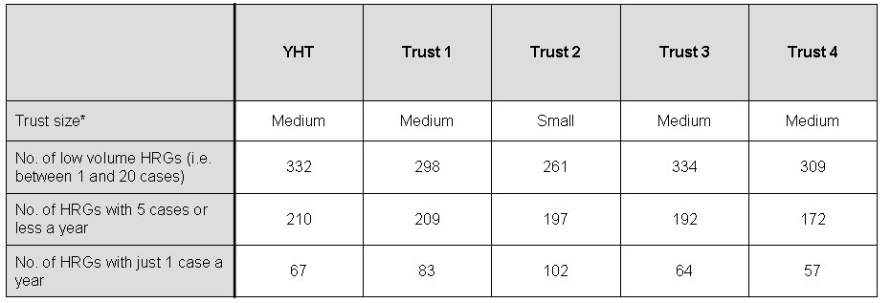
Trust size*: medium = 500 to 1500 beds, small = 500 beds or less

The table shows that for the five years in question, most trusts were doing at least half the possible 603 DRGs as low volumes. At times the volume was extremely low, for example, within YHT there were 67 DRGs with only one elective admission in a year. In Trust 2 (a small trust relative to the others) the number of DRGs for which only one admission per annum was recorded was 102.

Day Case Rates

As illustrated in Table 5, as with other Great Western Region Trusts, the proportion of elective activity performed as day cases (DCR) within YH Trust varied from the national average.

The data presented in Table 18 below shows the number of in-patient elective admissions that would have been treated as day cases in the event that DCR for each elective in-patient admission in YHT were either brought in line with (or increased to be better than) the national average.

The data show that improving the DCR for each DRG to be equal to the national average would have meant that 24% of the cases treated as elective inpatients would have been treated as day cases. Calculated on the conservative assumption that each in-patient admission converted into a day case would produce a bed day saving of one day only, this change in clinical practice at the very minimum would save 2,916 bed days (that is 1.2% of all trust beds days).

Table 18: day case ratio and potential savings for YH Trust in one year
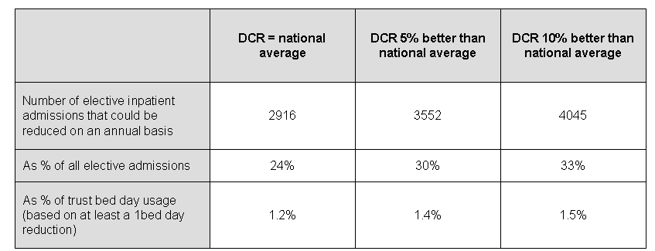

Allocative efficiency savings

The terms ‘allocative efficiency’ reference savings that would derive if chronic disease were better managed in primary care.

The extent of these savings become apparent when, for the same patient, we examined firstly, repeat admissions that occurred within the same DRG within one year and secondly multiple admissions that occurred within any DRG over a period of one year. Allocative efficiency savings were calculated by measuring the bed-day usage impact of a patient’s admissions (repeat and/or multiple) on the total volume of bed-days used by patients admitted through emergency. This impact, in turn, was established by comparing the observed rate of admissions (for a nominated DRG or collection of DRGs) with that predicted by a Poisson distribution.

The Poisson distribution is derived upon the assumption that the risk of having a repeat or multiple admissions is constant and independent (illness status is unchanged) for all admissions i.e. the risk of every patient being admitted once, twice, three, four etc times for a specific condition does not change over the time period, regardless of the number of previous admissions. The discrepancy between the Poisson distribution and the actual distribution can therefore be used to assess the risks of patients with a specific condition being admitted within a given time period. These risks can, by simple calculations, be ‘converted’ to represent bed days that could be saved if the patients’ repeat or multiple admission patterns reflected that of a Poisson distribution. The Poisson distribution assumes that:

- Each patient’s rate of readmission will be constant (given the severity of their condition at the original admission)

- When patients are independent and their re-admission rates remain unchanged over a fixed time period, then the distribution of (expected) re-admissions must conform to a Poisson distribution. Departures from a Poisson distribution for a particular condition may in this case be attributed to increases in the individual re-admission rates over the time period.

Repeat Admissions

This analysis focused on the rate at which patients with a specific condition such as, for example, COPD had further admissions for that same condition in the same year. Against this background we then calculated the bed-day savings that would be generated in the event that the observed rate of readmission was equal to an expected rate for the condition as projected by a Poisson distribution.

The results as set out in Table 19 show an annual saving of 2209 bed-days or of 6 beds per day equating to 0.8% of YH Trust’s total beds. The table shows that somewhat similar levels of saving would be derived by each of the other Trusts in the Great Western Region.

Table 19: Potential savings in emergency bed days by reducing repeat emergency admissions within the same DRG
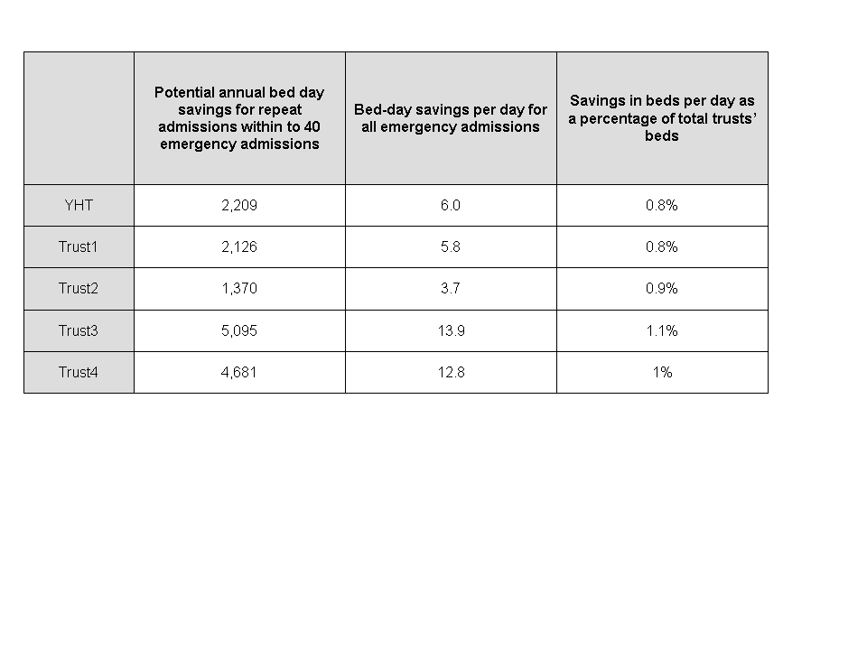

Multiple admissions

This analysis explored the extent to which a patient may have had several admissions for any condition including, for example not simply COPD but also angina or heart failure. Table 20 reports potential savings that would have derived if the observed rate of multiple admissions by individuals were reduced to the expected rate under a Poisson distribution.

Table 20: potential savings associated with multiple admissions for any DRG
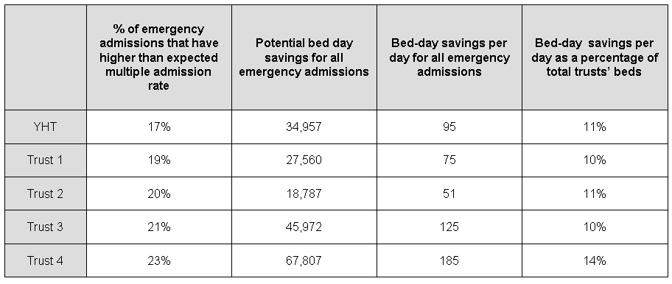

Within YH Trust the difference between the observed and expected rates of multiple admissions accounted for 17% of all emergency admissions; expressed as potential saving in beds per day, this equated to 95 beds or 11% of all HV Trust beds per day. The data again show that similar orders of savings were available in other Great Western Region Trusts.

Taken together Tables 19 and 20 indicate the extent to which admissions for different conditions were interrelated and how these interrelationships impact on emergency generated bed day usage. In essence, the data suggest that efforts aimed at reducing the rate of emergency admissions will be most effective when they focus not simply on individual conditions (repeat admissions) but on those patients with multiple conditions who are most prone to high emergency readmissions (multiple admissions).

Managing Demand

The foregoing analysis begs questions about the extent to which the rate of multiple emergency admissions for long term conditions varied by GP practice within a LHB. Figure 1 depicts the differences in rates of multiple admissions by GP practice for Smitherton LHB.

Figure 1: annual average observed multiple admissions for GP practices in Smitherton LHB
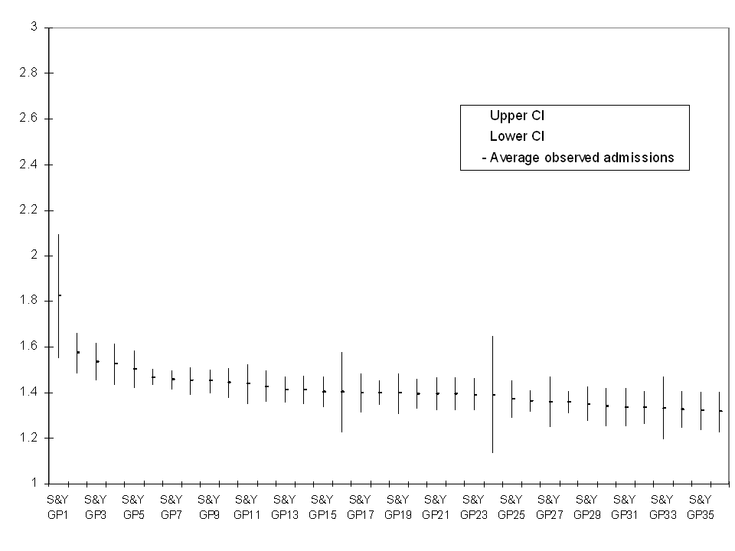

The figure shows significant differences between GP practices in the average observed rate of multiple admissions (S&Y GP1 with 1.82 admissions versus S&Y GP 35 with 1.31 admissions per patient per year).

The bed days that could have been saved if the observed rates of multiple admissions per GP practice were in line with the expected rate are displayed in Figure 2. The figure shows that for GP practices in Smitherton LHB these savings ranged from a 30% reduction in bed day usage to 8% per year. Some what higher orders of saving were available in the other LHBs.

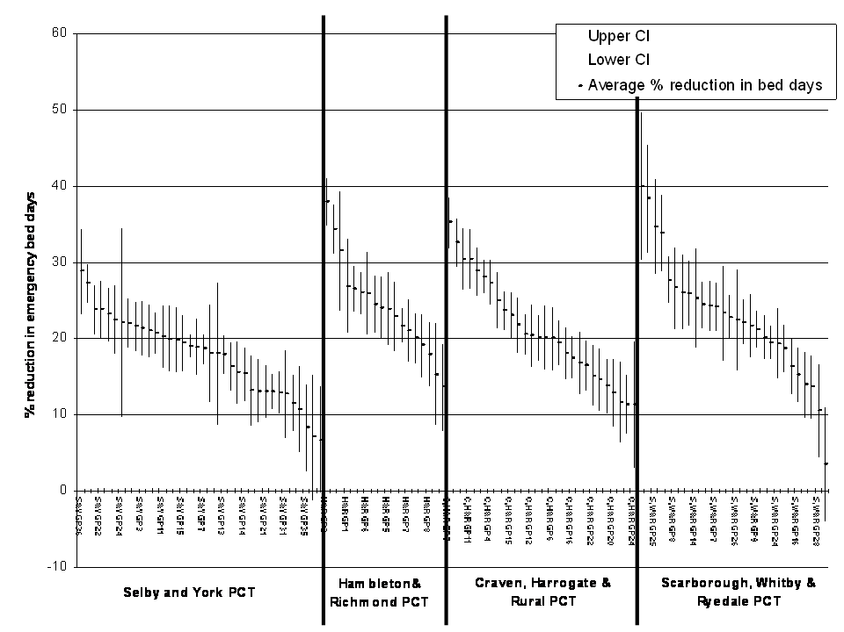
Figure 2: potential percentage reductions in bed days by LHB and GP Practice

The import of findings becomes clear when combined with earlier findings that

- 7 of the top 10 Accident and Emergency admissions to YH Trust reference conditions with a high risk of readmission and that
- admission for these ‘high risk re-admission’ DRGs accounts for about 15% of the bed days expended on all accident and emergency admissions

Taken together they point to the benefits that would derive to patients with chronic conditions whose management in primary care could be improved by integrated pathways that are structured to slow-down the progression of their underlying condition and/or reduce the rate at which they experience the acute exacerbations of their condition that lead to their admission to a hospital.
Summary of findings

Our analysis focused initially on high volume case types (in respect of emergency, elective, day case, maternity & birth admissions) that constitute the bulk of YH Trust’s workload. Our aim was to identify the case types for which integrated pathways might be developed and implemented to the benefit of improved quality, appropriateness and efficiency.

The data show that:

- 40 DRGs (out of 603) accounted for 46% of all emergency admissions and these DRGs accounted for 32% of all emergency generated bed days within the Trust;
- 14 of these top 40 emergency DRGs had high rates of repeat admissions over a one year period;
- 40 DRGs accounted for 60% of all elective inpatient admissions;
- 40 DRGs accounted for 84% of elective day cases; and
- 10 DRGs accounted for 98% of maternity (& birth) admissions and 97% of maternity and birth bed days.

These findings when taken together with findings on the technical efficiency gains that would derive bringing length of stay and day case rates to be in line with (or better that national rates) indicate that about 50% of the hospital’s inpatient (emergency and elective) and day case activity would benefit from the development and implementation of integrated pathways.

In a somewhat similar vein our analysis of repeat and multiple emergency admissions point to quality and efficiency gains that would derive (to both the health economy and patients with chronic conditions) via the development of integrated pathways that are structured to slow-down the progression of their underlying condition and/or reduce the rate at which they experience the acute exacerbations of their condition that lead to their admission to a hospital.

The extent of these technical and allocative efficiency benefits for YHT is outlined in Table 21 below.

Table 21: potential efficiency savings in YHT
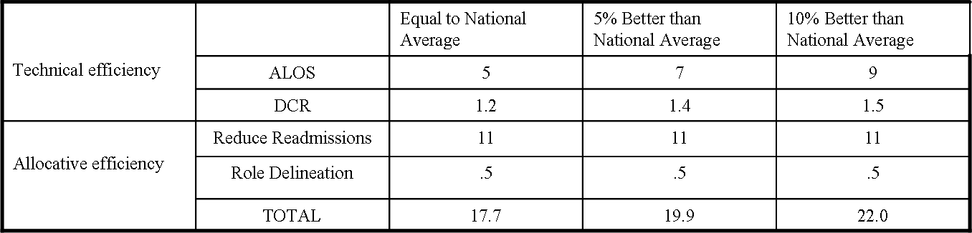

The data presented in Table 22 suggest that broadly similar savings are also available in the other Trusts within the Great Western Region

Table 22: potential bed day savings by Trust expressed as percentage of all beds within each Trust
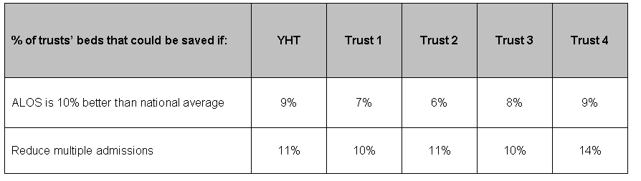

However while an ICP-based clinical management system, particularly for the high volume case types will provide the Trust’s clinicians and managers with means for realising improvements in quality and efficiency, our analysis also shows that the precise clinical conditions most suitable for pathway development and implementation would need to be determined via more detailed investigations (with clinicians) of the clinical conditions and/or procedures included within each DRG identified by their ICD10 or OPCS codes.

Finally the data for YH Trust, together with that from other Trusts in the region, point to quality and clinical governance issues posed by low volume elective admissions. These suggest that the Regional Purchasing Unit and its associated LHB should more closely define the clinical roles of individual hospitals within the Region.

